AIM

Measuring the Amount of Acetic Acid

In Vinegar

by Titration with an

Indicator Solution


This is to certify that Yashita Namdeo of class XII has completed the chemistry project entitled

‘DETERMINATION OF AMOUNT OF ACETIC ACID IN VINEGAR’ herself and under the guidance of the subject teacher and Lab incharge. The progress of the project has been continuously reported and has been in my knowledge consistently.



It gives me great pleasure to express my gratitude towards our chemistry teacher Miss Anuj and Miss Deepali for their guidance, support and encouragement throughout the duration of the project. Without their motivation and help the successful completion of this project would not have been possible.

Yashita Namdeo
12th A
32

Index

- Certificate

- Acknowledgement

- Aim

- Objective

- Introduction

- Materials and Equipment

- Theory

- Experimental Procedure

  - Experiment 1

  - Experiment 2

  - Experiment 3

- Result

- Precautions

- Bibliography
Objective

The goal of this project is to determine the amount of Acetic Acid in different types of vinegar using titration with a coloured pH indicator to determine the endpoint.
Introduction

Vinegar is a solution made from the fermentation of ethanol
(CH₃CH₂OH), which in turn was previously fermented from sugar. The
fermentation of ethanol results in the production of acetic acid
(CH₃COOH). There are many different types of vinegar, each starting
from a different original sugar source (e.g., rice, wine, malt, etc.). The

amount of acetic acid in vinegar can vary, typically between 4 to 6% for
table vinegar, but up to three times higher (18%) for pickling vinegar.

In this project, we will determine the amount of acid in different vinegars using titration, a common technique in chemistry. Titration is a way to measure the unknown amount f a chemical in a solution (the titrant) by adding a measured amount of a hemical with a known concentration (the titrating solution) The titrating solution reacts with the titrant, and the endpoint of the reaction is monitored in some way. The concentration of the titrant can now be calculated from the amount of titrating solution added, and the ratio of the two chemicals in the chemical equation for the reaction.

To measure the acidity of a vinegar solution, we can add enough hydroxyl ions to balance out the added hydrogen ions from the acid. The hydroxyl ions will react with the hydrogen ions to produce water. In order for a titration to work, we need three things:

- a titration solut on (contains hydroxyl ions with a precisely known concentration),

- a method for delivering a precisely measured volume of the titrating solution, and
- a means of indicating when the endpoint has been reached.

For the titrating solution, we'll use a dilute solution of sodium hydroxide (NaOH). Sodium hydroxide is a strong base, which means that it dissociates almost completely in water. So for every NaOH
molecule that we add to the solution,we can expect to produce a hydroxyl ion.

To dispense an accurately measured volume of the titrating solution, we will use a burette. A burette is a long tube with a valve at the bottom and graduated markings on the outside to measure the volume contained in the burette. The burette is mounted on a ring stand, directly above the titrant solution (as shown in the picture).

Solutions in the burette tend to creep up the sides of the glass at the surface of the liquid. This is due to the surface tension of water. The surface of the liquid thus forms a curve, called a eniscus. To measure the volume of the liquid in the burette, always read from the bottom of the meniscus.

In this experiment, we will use an indi ator solution called phenolphthalein. Phenolphthalein is olourless when the solution is acidic or neutral. When the solution becomes slightly basic, phenolphthalein turns pinkish, and then light purple as the solution becomes more basic. So when the vinegar solution starts to turn pink, we know that the titration is complete.
Materials and

Equipment

To do this experiment we will need the following materials and equipment:

Vinegar, three different types.

Distilled water

Small funnel

0.5% Phenolphthalein solution in al ohol (pH indicator solution)

0.1 M sodium hydroxide solution

125 mL Conical flask

25 or 50 mL burette

10 mL graduated cylinder

Ring stand

Burette clamp

Theory

- Required amount of sodium hydroxide (NaOH) can be calculated

using the following formula:
_{W} Molarity Molarmass Volume(cm³ )

1000
Molar mass of NaOH = 40 g/mol
- 0 .5 40 500

1000

  - 10 g

- The acetic acid content of a vinegar may be determined by titrating a vinegar sample with a solution of sodium hydroxide of known molar concentration (molarity).

CH3COOH(aq) + NaOH(aq) --> CH3COONa(aq) + H2O(l)
(acid) + (base) --> (salt) + (water)

At the end point in the titration stoichiometry between the both solution lies in a 1:1 ratio.
^{M}CH ₃ COOH^{V}CH₃ COOH 1

^{M}NaOH^{V}NaOH ¹

- Strength of ac d n vinegar can be determined by the following formula:

Strength of acetic acid = M _{CH3} _{COOH} 60 Indicator:- Phenolphthalein

End Point:- Colourless to pink
Experimental

Procedure

Performing the Titration

- Pour 1.5 ml of vinegar in an Conical flask.

- Add distilled water to dissolve the vinegar so that the volume of the solution becomes 20 mL.

- Add 3 drops of 0.5% phenolphthalein solution.

- Use the burette clamp to attach the burette to the ring stand. The opening at the bottom of the burette should be just above the height of the Conical flask we use for the vinegar and phenolphthalein solution.

- Use a funnel to fill the burette with a 0.1 M solution of sodium hydroxide.

- Note the starting level of the sodium hydroxide solution in the burette. Put the v negar solution to be titrated under the burette.

- Slowly drip the solution of sodium hydroxide into the vinegar solution. Swirl the flask gently to mix the solution, while keeping the opening underneath the burette.

- At some point we will see a pink colour in the vinegar solution when the sodium hydroxide is added, but the colour will quickly
disappear as the solution is mixed. When this happens, slow the burette to drop-by-drop addition.

- When the vinegar solution turns pink and remains that colour even with mixing, the titration is complete. Close the tap (or pinch valve) of the burette.

- Note the remaining level of the sodium hydroxide solution in the burette. Remember to read from the bottom of the meniscus.

11. Subtract the initial level from the re aining level to figure out how much titrating solution we have used.

- For each vinegar that we test, repeat the titration at least three times.
EXPERIMENT – 1

- Take the household vinegar in the conical flask and do the titration with sodium hydroxide (NaOH) as mentioned.

OBSERVATIONS
 | S.no |  | Volume of |  |  | Burette Reading |  |  |  |  |  | Volume of
 |  |  | vinegar |  |  |  |  |  |  |  |  | NaOH
 |  |  |  |  |  | Initial |  |  | Final |  |  | NaOH
 |  |  | solution |  |  | Initial |  |  |  |  |  | solution
 |  |  |  |  |  | (in mL) |  |  | (in | L) |  | solution
 |  |  |  |  |  | (in mL) |  |  | (in | L) |  | used
 | 1. |  | 20 |  |  | 0 |  |  | 27 |  |  | 27
 | 2. |  | 20 |  |  | 0 |  |  | 27 |  |  | 27
 | 3. |  | 20 |  |  | 0 |  |  | 27 |  |  | 27
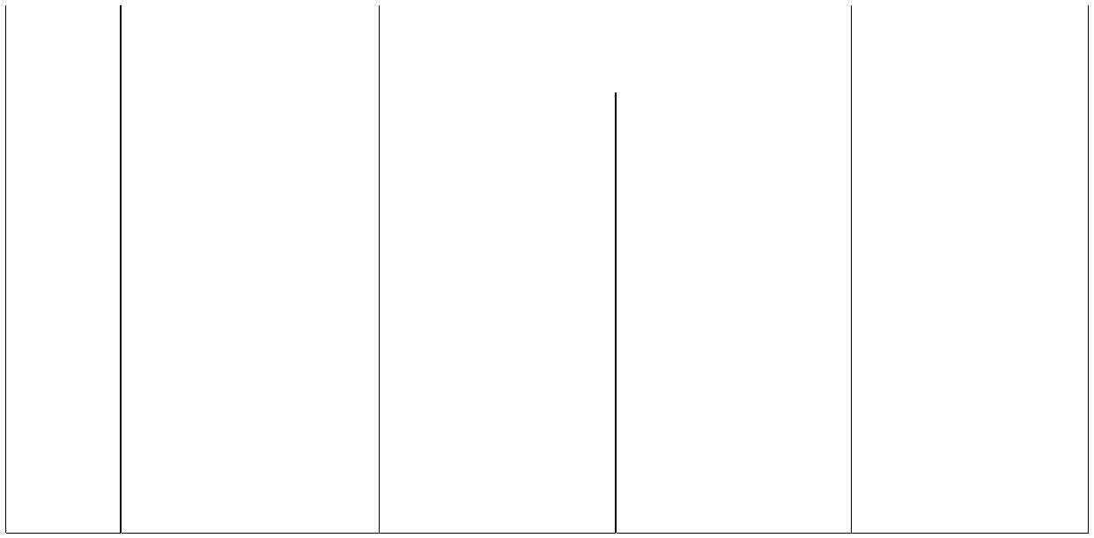

Concordant volume = 27 mL

CALCULATIONS

We know that,

^{M} CH ₃ COOH^{V}CH₃ COOH ^{M}NaOH^{V}NaOH
M _{CH COOH} ^{MNaOH} ^{VNaOH}

^{3V}CH₃ COOH

    - 27

^{M} CH ₃ COOH₂₀

  - 0.675 mol/L

Strength of acetic acid= 0 .675 60

=40.5 g/L
EXPERIMENT – 2

- Take the wine vinegar in the conical flask and do the titration with sodium hydroxide (NaOH) as mentioned.

OBSERVATIONS
 | S.no |  | Volume of |  |  | Burette Reading |  |  |  |  |  | Volume of
 |  |  | vinegar |  |  |  |  |  |  |  |  | NaOH
 |  |  |  |  |  | Initial |  |  | Final |  |  | NaOH
 |  |  | solution |  |  | Initial |  |  |  |  |  | solution
 |  |  |  |  |  | (in mL) |  |  | (in | L) |  | solution
 |  |  |  |  |  | (in mL) |  |  | (in | L) |  | used
 | 1. |  | 20 |  |  | 0 |  |  | 48 |  |  | 48
 | 2. |  | 20 |  |  | 0 |  |  | 48 |  |  | 48
 | 3. |  | 20 |  |  | 0 |  |  | 48 |  |  | 48

Concordant volume = 48mL

CALCULATIONS

We know that,

^{M} CH ₃ COOH^{V}CH₃ COOH ^{M}NaOH^{V}NaOH
M _{CH COOH} ^{MNaOH} ^{VNaOH}

^{3V}CH₃ COOH

^{M} CH₃ COOH |  | 0.5 48
 | 20

- 1.2 mol/L

Strength of acetic acid= 1. 2 60

=72 g/L
EXPERIMENT – 3

- Take the fruit(Persimmon) vinegar in the conical flask and do the titration with sodium hydroxide (NaOH) as mentioned.

OBSERVATIONS
 | S.no |  | Volume of |  |  | Burette Reading |  |  |  |  |  | Volume of
 |  |  | vinegar |  |  |  |  |  |  |  |  | NaOH
 |  |  |  |  |  | Initial |  |  | Final |  |  | NaOH
 |  |  | solution |  |  | Initial |  |  |  |  |  | solution
 |  |  |  |  |  | (in mL) |  |  | (in | L) |  | solution
 |  |  |  |  |  | (in mL) |  |  | (in | L) |  | used
 | 1. |  | 20 |  |  | 0 |  |  | 32 |  |  | 32
 | 2. |  | 20 |  |  | 0 |  |  | 32 |  |  | 32
 | 3. |  | 20 |  |  | 0 |  |  | 32 |  |  | 32

Concordant volume = 32 mL

CALCULATIONS

We know that,

^{M} CH ₃ COOH^{V}CH₃ COOH ^{M}NaOH^{V}NaOH
M _{CH COOH} ^{MNaOH} ^{VNaOH}

^{3V}CH₃ COOH

^{M} CH₃ COOH |  | 0.5 32
 | 20

- 0.8 mol/L

Strength of acetic acid= 0 .8 60

=48 g/L
Result

- Strength of acetic acid in household vinegar = 40.5 g/L.

- Strength of acetic acid in wine vinegar = 72 g/L.

- Strength of acetic acid in fruit vinegar = 48 g/L.

Graphically plotting various vinegar sa ples in accordance with the amount of acetic acid present in them we present a stunning find:
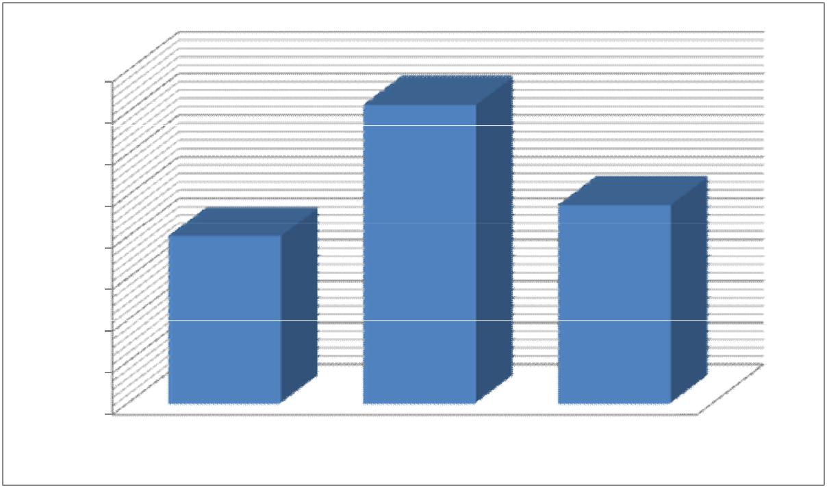

Strenth of Different Vinegars

80

70

60

50

40

30

20

10

0

Household V negar Wine Fruit Vinegar

Order of amount of acetic acid in different samples of vinegar is:

Wine > Fruit vinegar > Household vinegar

Precautions

- Transference of measured vinegar into a measuring flask should be done very carefully.

- Measuring must be performed carefully.

- Look at the meniscus of solution at eye level to avoid parallax.

- Look at the lower meniscus in the light coloured solution and upper meniscus in the dark coloured solution because of visibility.

- Do not forget to add distilled water to the vinegar.

Bibliography

www.icbse.com
chemistry class 12 textbook
Wikipedia

